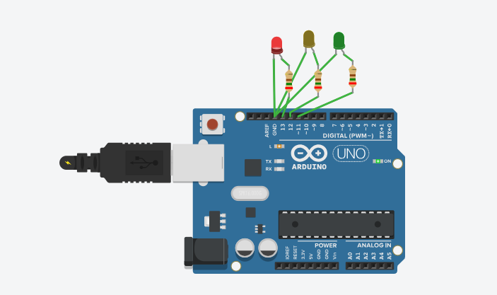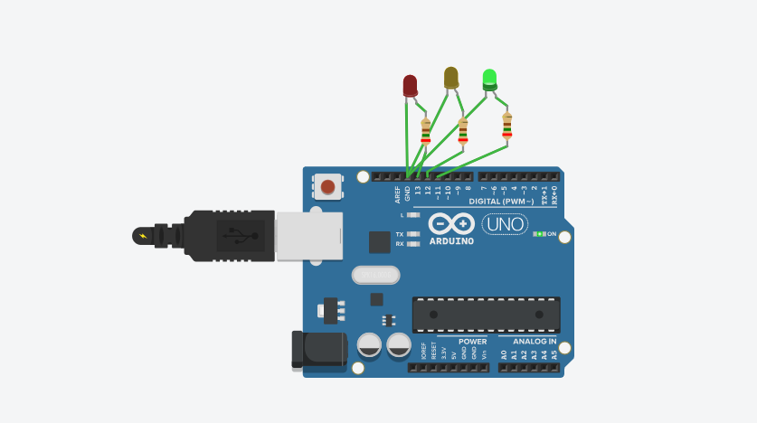

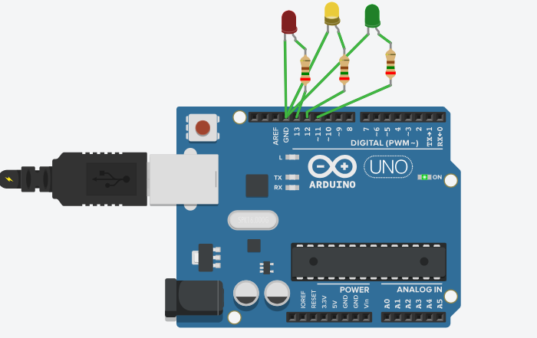

Red led:

Anode:pin 13

Cathode:ground

Yellow led:

Anode : pin 12

Cathode: ground

Green led:

Anode:pin 11